Advanced Software Engineering

Project Plan

Submitted by

Arimanda,Syamala Reddy

Boyanapalli,Swathi

Vakalapudi,Vinod Kumar

Katib,Rayan Faruq

1. **Introduction:**

“You Query We Answer” is an online based application that provides service to the students in order to plan their bright future. This application acts as a guide for the students in attending and achieving success in various exams and cope up with their grades or GPA. This application acts like an encyclopedia and allows the student to select a topic that is available and will give fetch the data giving an idea about the topic clearly along with the examples in various formats. Thus, making the student ready to face any kind of interview and help them to achieve their goals and help them achieve success.

1. **Project Goal and Objectives (revised)**

* **Overall goal**

Our project gives clear idea about many things that are necessary for a student at the time of choosing a school to pursue his degree and also after attending the school. We have many features in our project which provides many answers to various types of questions that were really necessary and helpful to the students at the selection process of a school. We divide various questions into some groups.

Example: Admission Procedure is a group in which it can answer many questions like

1. What are the steps to be followed to apply to the school?

Ans: student should have gre, toefl/ ielts score card, transcripts, sop, lor etc.

2. What are the required scores that are mandatory to apply?

Ans: gre 300+ particularly having quant score more than 160 and Toefl with a score of 100 minimum or ielts with minimum of 6.5

3. Is the school accepts ielts score less than 6.5?

Ans: Yes, the school will also accepts the score of 6 but student must have to attend a test i.e., ALI.

Once the student decides his school then he will be provided with model test papers of both the gre and toefl/ielts exams with all the sections covered in it.

Example: We provide sections like quant, verbal, analytical writing under gre exam and sections like speaking, listening, writing and reading under toefl exam.

* **Specific objectives (problem statement)**

All the sites in the internet will have their own questions for different topics that are necessary for attending an exam or an interview, but it is very difficult to access all the sites and the topics to prepare from. Even knowing & choosing the sites in the proximity is also tough. It is also tough to compare two sites and the different models and various levels of questions in it. Thus, our project makes the search easy.

* **Significance**

1. Our project completely provides the details of the various buildings, departments that were located in the campus with the help of maps.
2. Our project helps the students to have all the details about the admission procedure. All the required marks in the competitive exams like gre and toefl and the required GPA to get the admission in the school.
3. The student can track the status of their application by the identification number that was provided by the school.
4. A student can also have the possibility to know whether he is eligible for the scholarship/funding and also the requirements for getting a scholarship.
5. Students are provided with all the required material i.e., model questions for the competitive exams like gre and toefl which are essential for a student admission.

**III. Project Background and Related Work**

We find a number of websites having their own online guides for preparing and achieving in various exams or interviews service like<http://www.majortests.com>. In this portal, the students have the facility to search for a particular exam, topic, various sections and levels in it. Currently, we find no such online service providing these services. Our project will be solution for this.

IV. Proposed System

1) Requirement Specification:

**Functional Requirements (Prioritized):**

* Users can register with their details, login and then update their profile if required.
* Students can choose the required exam and under that the required category in the website.
* Navigation and route maps are provided to the students about the universities.
* Statistics are provided to the students at different categories of exams like gre and toefl.

**Non-Functional Requirements:**

* Our online service will be student friendly and easy to use.
* available on every day i.e., 24*7
* Loading our web application is fast as it uses very less bandwidth.

Business Process/Workflow analysis

* Students register and get login with their credentials.
* After choosing the particular university in the catalogue they can check for the required cutoff for exams like gre, toefl etc.
* If the student selects the university, he can view the map and all through Google maps.
* Student can select the practice tests and can access their level through the feedback.
* They can retake the particular section to improve their marks in particular section for free.

Technological and Architectural requirements

1. User interface(Web Frame):

* HTML
* CSS
* Java Script
* .NET
* PHP

2. Back End: UMKC Website

3. Web Services:

* Microsoft Visual Studio 2010 ( C#)
* Mash up
* UMKC Server

4. Testing: NUnit

5. UML /Architecture Diagrams: Microsoft Visio 2013

6. Planning: Scrumdo

7. Databases: SQL Server

2) Framework Specification: Build an overall system model

Methodologies and Algorithms

Our project requires changes very frequently. So in order to make our application more creative we use Scrum which is an important agile methodology.

System Architecture Diagram

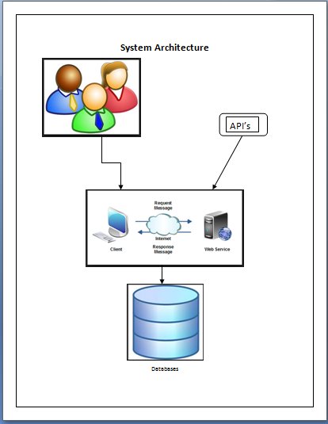

3) System Specification:

Existing Services:

|  |  |  |  |
| --- | --- | --- | --- |
| S.No | Name | Description | URL |
| 1. | Google Maps | To have the geolocation of the school | https://maps.googleapis.com/maps/api/directions/output?parameters |
| 2. | Google Search Engine | To search the required information for the student | https://ajax.googleapis.com/ajax/services/searc  h/web?v=1.0&q= |

**New Services to be built:**

Login: To authenticate the student and the admin login.

Update-User: To update the user profile.

Update-Database:To update the exams and the feedback to provided to the user.

Retrieve:We get the data according to the users search criteria.

**Use Case Diagram:**

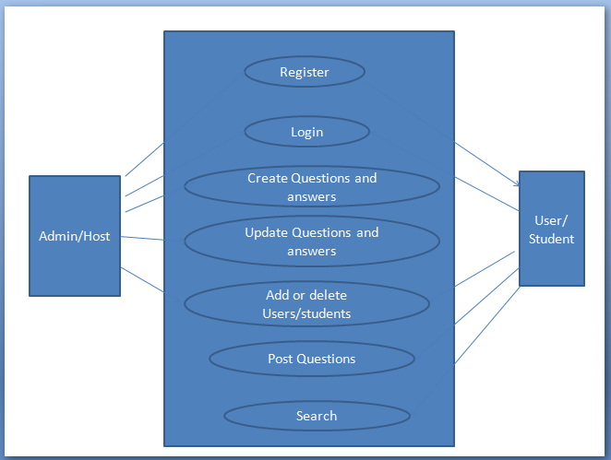

Activity Diagram

Admin activity:

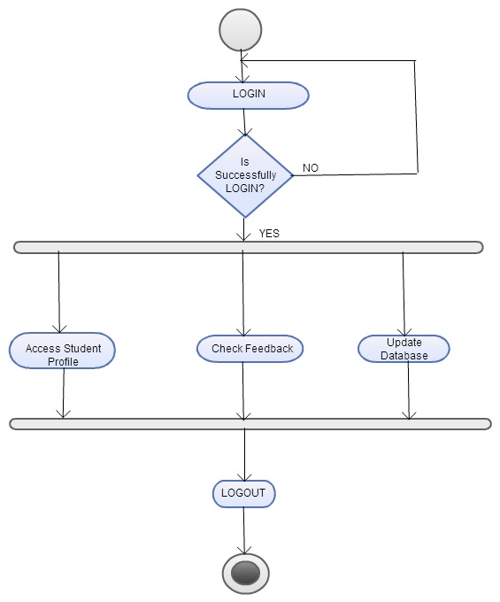

Student activity:

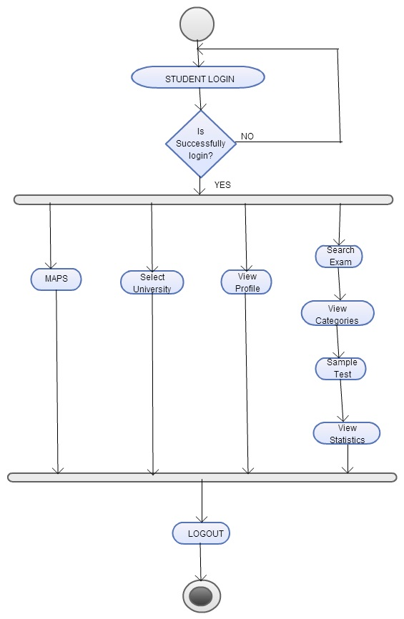

Service Specification

* Operational description

Students login for the web application updates their profile, assess their skills using practice tests etc. where the admin login to update the database, view students profile etc.

* Input/output for services

Input will be the data entered by the user to search for a school and output will be the tests and the suggestions given to students.

* Design of Mobile Client

Students can update their information and select universities based on their range and can prepare for the tests through practice tests whereas admin can update the database.

* Features, Styles, Technologies

JAVA, C#, ASP.NET, SOAP Web Services

VI. Risk management

* Services need to be fast and reliable
* Everything need to be updated i.e., the databases should be updated based on the students choice.
* All the information should be compatible on both the phone and the website.
* Multiple transactions and parallel applications must be carried out.

VII..Planning: Scrumdo

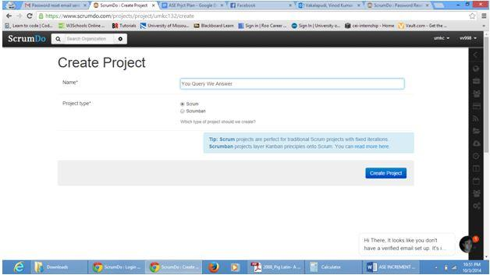

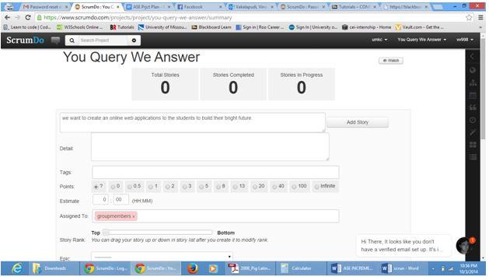

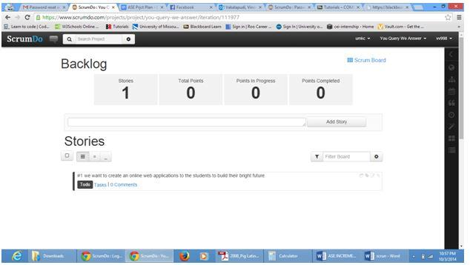

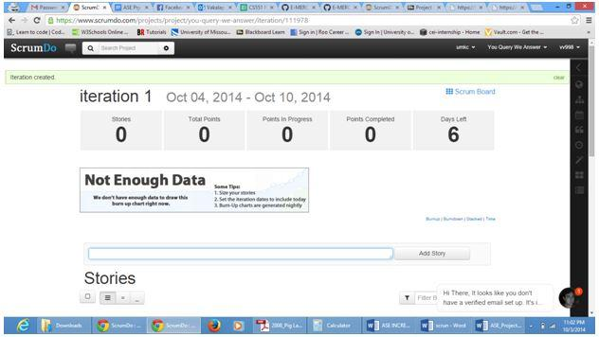

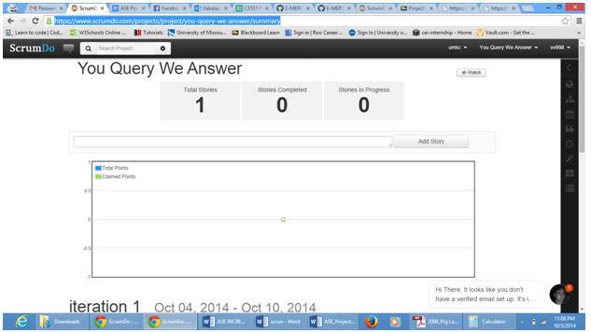

Scrumdo url: <https://www.scrumdo.com/projects/project/you-query-we-answer/summary>

VII. Bibliography

[www.google.com](http://www.google.com)

<http://msdn.microsoft.com/en-us/vstudio/aa718325.aspx>

<http://www.w3schools.com/>

<http://msdn.microsoft.com/en-us/library/vstudio/4w3ex9c2(v=vs.100).aspx>